**FASTEST FINGER FIRST INDICATOR**

PBL Report

***Submitted******By***

1.PRATHAM [4NM20EE055]

2.KANZAL HAQ A [4NM20EE032]

3.RUHBAN [4NM20EE011]

4.CHANDAN B [4NM20EE013]

5.AJITH [4NM20EE002]

6.RAGHAVENDRA [4NM20EE060]

***Project Guide***

Dr. K. Latha Shenoy (E&E NMAMIT)

## *Abstract*

In the buzzer round of quiz contests, the question is thrown open to all the teams. The person who knows the answer hits the buzzer first and then answers the question. Sometimes two or more players hit the buzzer almost simultaneously and it is very difficult to detect which of them has pressed the buzzer first. For this reason, we are using 7segmnent display in the place of buzzer, which displays fastest player or team.

In the round of any quiz contest question are thrown open to all the participating teams. Each team has a push button switch. After hearing the question any member of a team who knows the answer and hits the switch first gets a chance to answer. In multiple cases who hit the switch first gets the opportunity to reply. For next round the quiz master reset the buzzer operation circuit by pressing the reset switch. For visual indication we use 7 segment display. The 7segment display displays team(player) number. Quiz master resets the display to 0 using reset button.

***Block Diagram***

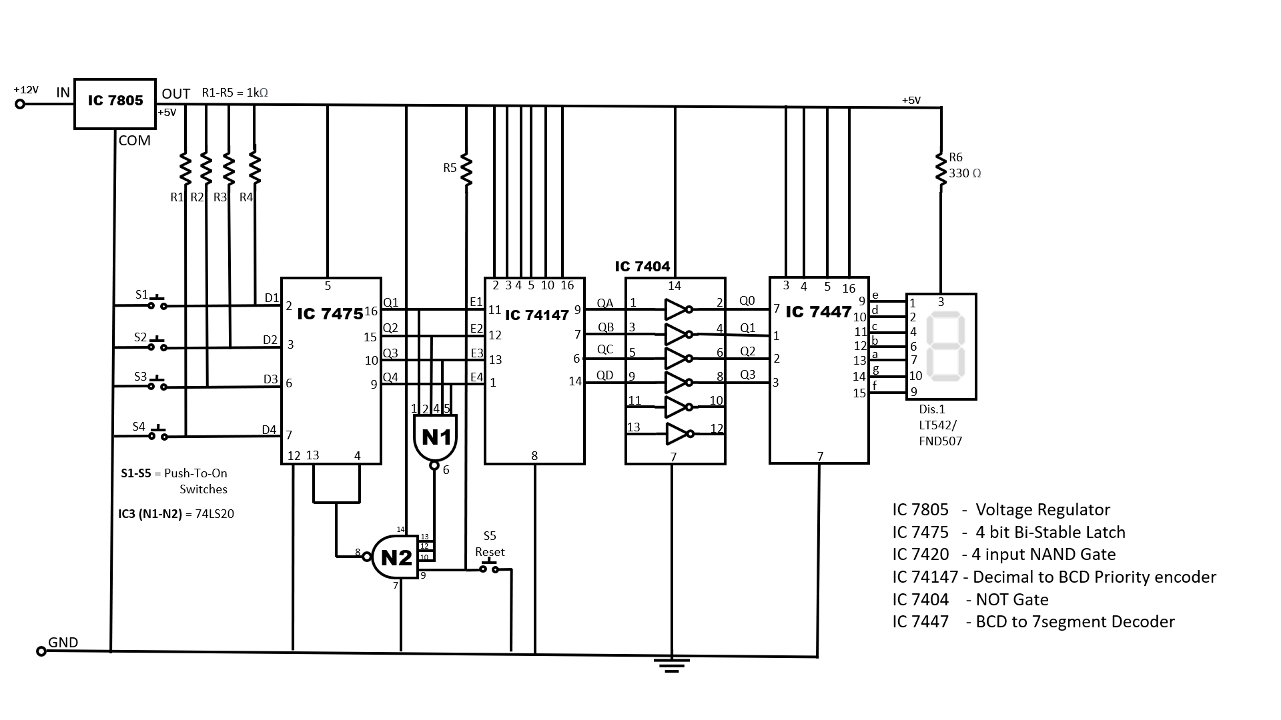

***Working of Fastest Finger First Indicator***

In the above circuit we use the ICs which require 5v Vcc, for the stable input voltage we use voltage regulator IC 7805(5v regulator). Initially one terminal of 4 switches is shorted connected to ground and other terminals are given as input(D1-D4) to the IC 7475(4 bit Bi-Stable Latch) and also connected to Vcc using 1k

Ω to act as debouncer. So output(Q1-Q4) of IC 7475 will be Logic 1.

|  |  |  |  |
| --- | --- | --- | --- |
| D – Latch Truth Table | | | |
| E | D | Q | Q’ |
| 0 | 0 | Latch | Latch |
| 0 | 1 | Latch | Latch |
| 1 | 0 | 0 | 1 |
| 1 | 1 | 1 | 0 |

|  |  |  |
| --- | --- | --- |
| NAND Gate Truth Table | | |
| A | B | Output |
| 0 | 0 | 1 |
| 0 | 1 | 1 |
| 1 | 0 | 1 |
| 1 | 1 | 0 |

Since outputs are connected to NAND Gate , ouput of N1 is logic 0 which is given as input to N2 in which one input is directly taken from Vcc and its also connected to Reset switch(debouncer condition).The output of N2 will be logic 1, which is connected to pin 4&13 of IC 7475, this is enable pin for IC 7475.

Lets assume switch 2 is pressed by the player no.2 very fast, at this instant Q2 will be logic 0. By this, enable will become zero. If enable is zero IC 7475(4 D-Latches) it does not take any input and it will store previous out input until enable become logic 1.

Input for IC 74147(Decimal to BCD priority encoder) will be 1101.Since this encoder takes 9 iputs, remaining inputs are connected to Vcc.

This IC will covert decimal to Binary number that is 1101(DCBA).But now switch is pressed by player 2, we should display give 0010 in 7segment. So we use Inverter that is NOT Gate IC 7404. This will convert 1101🡪0010.

|  |  |  |  |  |  |  |  |  |  |  |  |  |  |
| --- | --- | --- | --- | --- | --- | --- | --- | --- | --- | --- | --- | --- | --- |
| Decimal to BCD Priority encoder | | | | | | | | | | | | | |
| 1 | 2 | 3 | 4 | 5 | 6 | 7 | 8 | 9 | D | C | B | A |
| X | 0 | 1 | 1 | 1 | 1 | 1 | 1 | 1 | **1** | **1** | **0** | **1** |

|  |  |  |  |  |  |  |  |
| --- | --- | --- | --- | --- | --- | --- | --- |
| Output of NOT IC 7404 | | | | | | | |
| D | C | B | A | D’ | C’ | B’ | A’ |
| 1 | 1 | 0 | 1 | 0 | 0 | 1 | 0 |

The outout of IC 7404 is given as input to IC 7447(BCD to 7segment Decoder) this IC will drive the 7segment display.Hence 7segment display will display No.2.

|  |  |  |  |  |  |  |  |  |  |  |  |
| --- | --- | --- | --- | --- | --- | --- | --- | --- | --- | --- | --- |
| Output of IC 7447 | | | | | | | | | | | |
| Decimal No. | D | C | B | A | a | b | c | d | e | f | g |
| 2 | 0 | 0 | 1 | 0 | 0 | 0 | 1 | 0 | 0 | 1 | 0 |

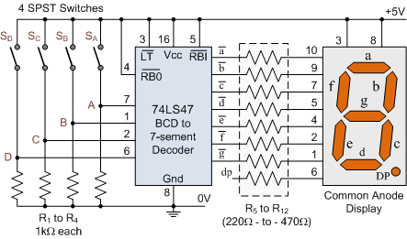

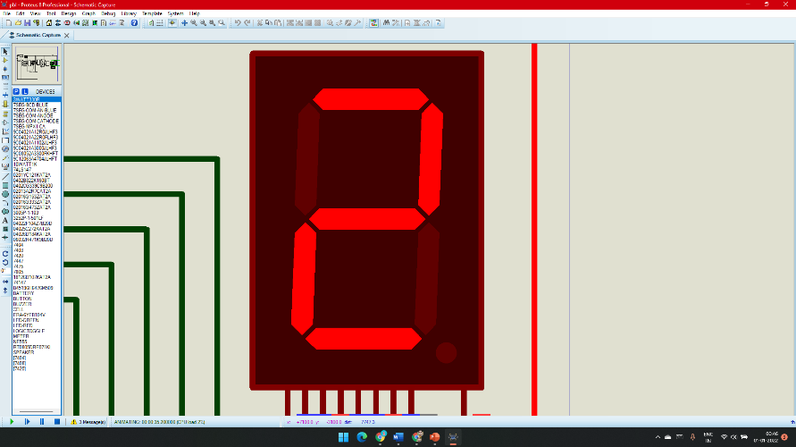

Output in 7segment Display 🡪

We are using Common Anode7 segment Display

If the quiz master wants to go to next round he will push the reset switch, enable will become logic 1,which will display zero in 7segment display.

We can also increase the number of players by using required additional ICs.

***Conclusion***

Projection has been successfully completed and tested for the output, we are verified for the above condition and also for other 3 condition.